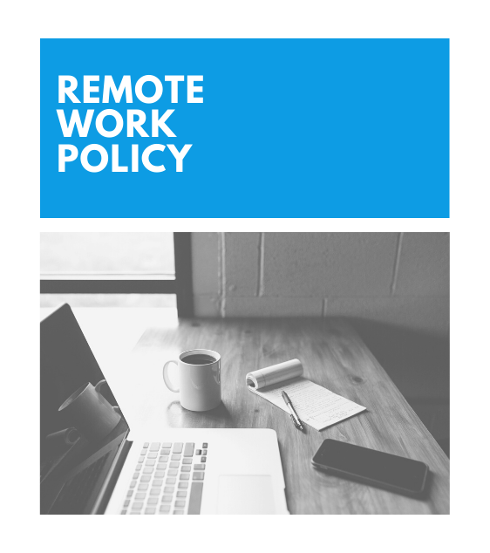
Disclaimer: Policy should be reviewed by legal counsel to ensure that all local, state, and federal regulations have been met. Please do so before making it available to your employees.
REMOTE WORK POLICY

Please review the terms and conditions, complete the attached form, and return to your manager for approval.
BACKGROUND
Our Company began offering remote work in 2014. This policy serves as a guide to help all of our employees to help understand the expectations of working remotely at Our Company, and feel well-supported throughout their experience. We have continued to update this policy based on employee feedback, and encourage any questions or comments!
WHO IS ELIGIBLE TO WORK REMOTELY?
At Our Company, we trust you to do your job well from wherever you may be, and want to ensure that you have all of the tools and support you need to do so. We certainly believe that great work can be done remotely, but also value the time that our teams have in-office and together.
We will typically determine if a position is remote, hybrid, or in-office at the very start of the recruiting process. That being said, we know that situations change, and encourage any employee to discuss their specific needs and schedule with their manager or HR. We allow each department manager to have the final determination of whether or not the individual and/or the role can function well and perform essential duties on a remote basis. (An office administrator role will likely require an in-office or hybrid schedule, for example.)
Any position can request the ability to work in the office, work from home permanently, or work on a hybrid schedule. To do so, simply set up a meeting with your direct manager to discuss those options. Note that your current performance, team needs, and business needs all factor into whether or not the request will be approved, and each request will be assessed on a case-by-case basis.
If you are interested in relocating or planning to relocate to a different state, please discuss it with your manager and/or HR, even if you’re already in a full-time remote position!
If your current situation requires you to work from home or remotely on a temporary basis, you can also follow this same process.
WORKING HOURS, ATTENDANCE, & AVAILABILITY
For Full-Time Remote Employees
Regardless of whether the role is remote or in-office, all full-time employees are required to work 40 hours per week and attend any required quarterly or annual meetings on-site.
For Hourly Remote Employees
Hourly, non-exempt employees will still need to accurately record all hours worked and submit those records to their managers to ensure they’re properly compensated.
The Fair Standards Labor Act (FSLA) requires us to compensate their employees for all hours worked, including overtime hours. This principle applies equally to remote work, but this only applies if we know or have reason to believe that work is being performed. That’s why it’s important to log into your time-tracking software or tool and ensure that it’s all documented!
Note: As always, overtime hours require the advance approval of your manager.
For All Remote Employees
We trust all of our employees to get their work done. Whether or not you’re available or “online” isn’t a matter of oversight or a lack of trust; it’s about being excellent to your teammates and available if needed. Your team should know whether or not they can reach you in an emergency or time of need, and if your work is covered.
Achieving this requires a few additional steps in a remote environment, but here are a few things we have often suggested: (1) Zoom standups, (2) a Slack channel where individuals can post their availability (out to lunch, etc.) or just utilizing Slack statuses, and (3) diligent use of your calendar and working hours/vacation time.
You should also ensure your calendar has regular 1-on-1s and team meetings each week, giving each team member the opportunity to see one another and meet with their manager.

COMMUNICATION
Because you’re not next to one another in an office, any remote employee should err on the side of overcommunication. Slack, email, Zoom, phone calls, and numerous other communication channels are available to you.
Your team and manager will likely have their own expectations for communication and response times; be sure you know what those are. If those expectations seem unreasonable, please discuss them with HR.
ENVIRONMENT
It is the responsibility of the employee to designate a remote workspace, which is typically a space in your home (an office, spare bedroom, etc.). No work should be performed outside of this designated workspace. The designated workspace must be kept in a safe condition, free from hazards to both the employee and the equipment.
If you sustain any injuries in their designated workspace and in conjunction with your regular work duties, notify your manager of such injuries as soon as possible. Our Company is not responsible for any injuries to the employee or any third parties outside of the designated workspace or during the employee’s non-working time.

If, while working from a designated workspace, the employee experiences technical issues with his or her computer or internet access that prevent the employee from working remotely, the employee should notify his or her manager right away to ensure coverage of the work and to get support for the issue. If youInterruptions to work caused by internet outages may require the employee to work from the main office or an alternate location for the remainder of the day, or until the outage is fixed.

Employees working from a designated workspace may, from time to time, be required to come to their usual work site as required by the needs of the business.
You’re expected to make appropriate child-care arrangements during your work hours. We understand that exceptions happen and family issues come up, so please talk to your manager or HR if there are any extenuating or temporary circumstances that you need assistance with! We’re always here to help.
PERFORMANCE EXPECTATIONS
The performance expectations for a remote employee are no different than for an in-office employee.
EQUIPMENT
All remote employees must utilize company laptops to perform their work. We will provide you with a laptop, which will also contain necessary software and programs. Any other necessary equipment is available for loan upon request (additional monitors, keyboards, etc.). Our Company is only responsible for ensuring items on loan; personally-owned equipment should be covered by your individual homeowner’s insurance policy.
In order to receive reimbursement for expenses, you should have prior approval from a supervisor and submit an expense report.
We understand that you may want to use your own devices for work (phone, tablet, etc.) Secure data management procedures (including passwords and encryption) should be enforced on all devices, especially your personal devices. In addition to that, you may be required to register your cell phones and laptops with the IT team. If your personal device is stolen or lost, please notify us as soon as possible.

STIPEND
We provide every employee with a remote work stipend of $150/month, which can be used towards additional office equipment, daycare, a coworking pass, coffee, and anything else that makes your remote work locations more comfortable, productive, or successful. It can also be used to purchase the general perks that our in-office locations have access to, including food, health and wellness, or learning and development.
In addition to the monthly stipend, we offer all remote employees an initial $500 stipend to set up their home office area with a desk, a great chair, etc.
If you have questions about whether or not your remote stipend covers a certain purchase, don’t hesitate to ask your manager or HR!
SECURITY AND CONFIDENTIALITY
You are responsible for keeping documents, sensitive business data, and other work-related materials confidential and secure in your home office location. As always, comply with the guidelines of proper use of information technology (which can be found in our Employee Handbook).
For security purposes, no work can be done on a public Internet connection. Nor can any work be performed on non-company equipment. This is to make sure that the data of our customers and of our business is kept as private as possible.
OTHER
All of Our Company’s rules and policies, including those set in our Employee Handbook, apply while working from a designated workspace. These policies include, but are not limited to, policies regarding attendance, confidentiality, and policies prohibiting harassment. Employees are reminded that this remote/work-from-home policy is not to be used in place of sick leave, FMLA leave, etc. All of our guidelines for employee benefits and compensation remain the same.

TERMINATION OF AGREEMENT
Both the company and the employee have the right to terminate the remote work agreement at any time - by written or verbal notice. Failure to comply with the above terms and conditions may be cause for disciplinary action and/or termination of your agreement.

REMOTE WORK AGREEMENT
A. EMPLOYEE INFORMATION

Full name: | ______________________________________________________________________________________
Job title: | ______________________________________________________________________________________
Department: | ______________________________________________________________________________________
HR contact: | ______________________________________________________________________________________
Supervisor: | ______________________________________________________________________________________

B. DESIGNATED WORK AREA

Address: | ____________________________________________________________________________
Phone number: | ____________________________________________________________________________
Description of workspace: | ____________________________________________________________________________

C. REMOTE WORK SCHEDULE & HOURS

DAY | START | END
Monday
Tuesday
Wednesday
Thursday
Friday
Saturday
Sunday

D. REQUEST FOR COMPANY EQUIPMENT

The following items have been approved for purchase/loan: _____________________________________________________________________________________________________________________________________________________________________________________________________________________________________________________________________________________________________________________
E. AUTHORIZATION FOR REMOTE WORK
I have read and I agree to the Terms and Conditions of this policy, and I agree to the duties, responsibilities, obligations, and conditions outlined in these documents. Should any changes occur to the information I have provided above, I am aware that it is my responsibility to inform my supervisor and Human Resources to initiate completion of an updated agreement. I understand that a copy of this agreement will be kept in a personnel file.
Employee Signature: __________________________________________________________________________________
Supervisor Signature: __________________________________________________________________________________
HR Contact Signature: _________________________________________________________________________________
Date: _________

