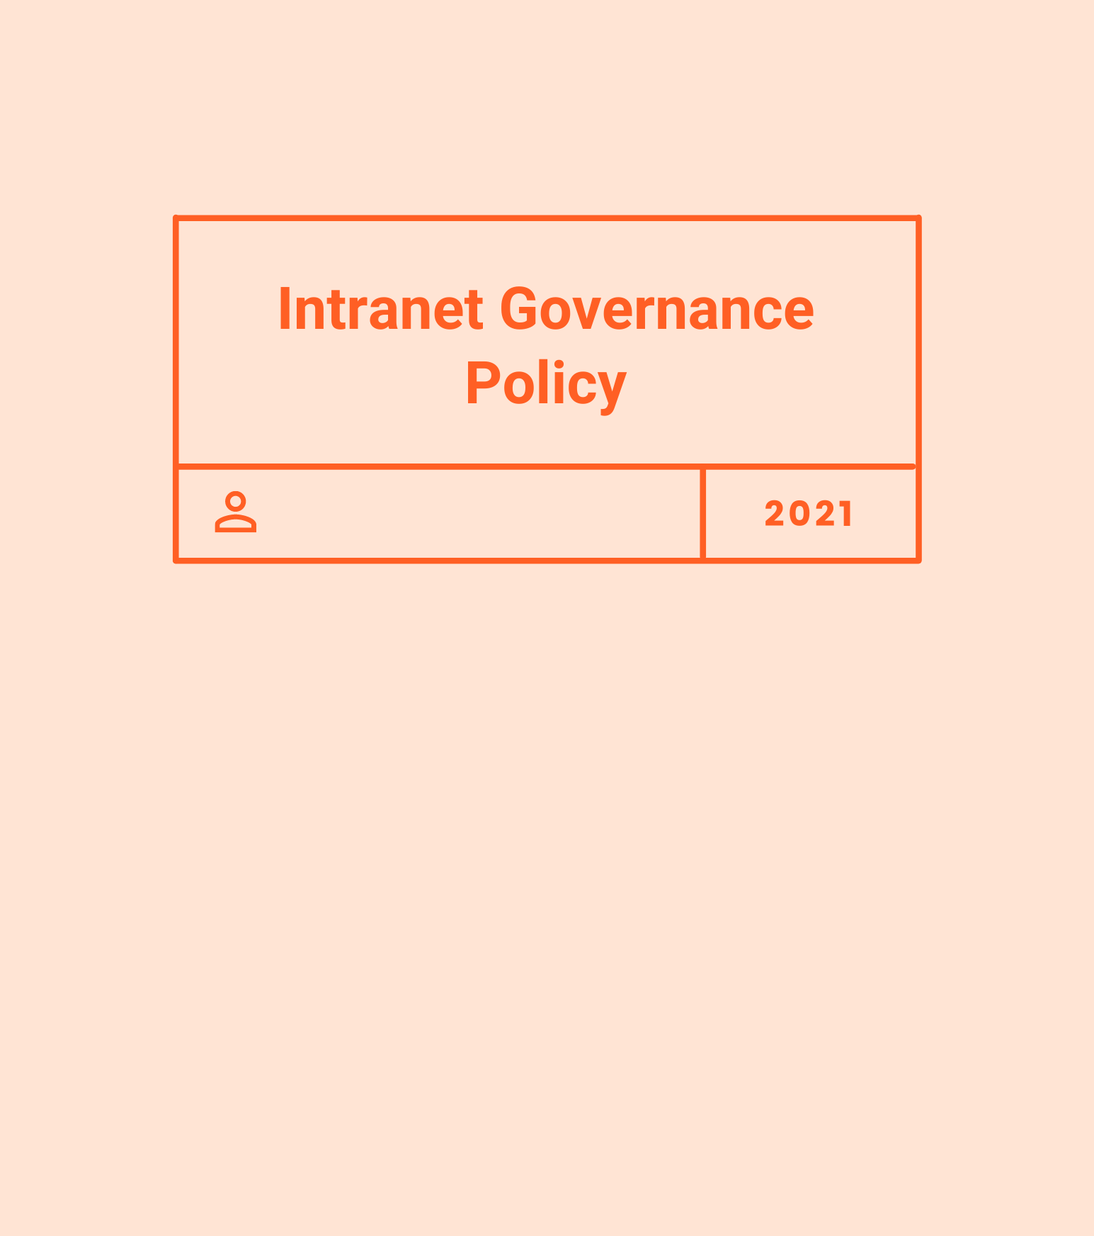
Disclaimer: Policy should be reviewed by legal counsel to ensure that all local, state, and federal regulations have been met. Please do so before making it available to your employees.

Policy Owner | Effective Date | Last Reviewed | Next Review Date
VP of Marketing | 4/5/2020 | 12/15/2020 | 5/1/2021

ABOUT THIS GUIDE
We are passionate about transparent, effective communication and encourage the sharing of information among all employees and departments within COMPANYNAME. To facilitate this, COMPANYNAME is committed to supporting and maintaining our Workshop, an internal website that provides a collaborative and respectful forum for departments and employees to share timely and accurate information. It is designed for the use and benefit of employees at COMPANYNAME, to assist in their day-to-day work and to help support our company goals and objectives.
This policy clarifies the intranet governance structure for Workshop, as well as its intended use.

PURPOSE & STRATEGY

At COMPANYNAME, our intranet serves three key purposes:
- to give our teams easy access to the relevant information and tools they need to do their jobs well
- to build community and collaboration, in order to further our mission
- to encourage dialogue and knowledge sharing within COMPANYNAME

ROLES & RESPONSIBILITIES
The following roles represent our formal “steering committee.” This committee will occasionally meet to sign off on new or changing strategies, make major decisions, and ensure the intranet is continuing to support our company’s goals.
- The VP of Marketing has overall responsibility for our intranet.
- The Chief Product Officer has the final decision with respect to the look, feel, navigation, and functionality of the intranet.
- The Internal Communications Manager is responsible for the homepage resources of our intranet. They will also work with all department heads regularly to ensure they add and update the information for their particular teams and/or news streams.
- The Internal Communications Manager will perform a periodic review of information on the intranet (including profile images), moderation of updates and commenting, analyzing employee usage data, and more. They will delete or archive information that is out-of-date or not regularly used.
- The Internal Communications Manager will be responsible for monitoring compliance with, and the effectiveness of, this policy.
- The IT team has responsibility for providing technical support and training for the intranet and for addressing technical issues that could come up for any employees using the intranet.
- The HR Director will continuously monitor our intranet and raise any issues with the relevant areas.
- Department managers and other content authors have the responsibility for maintaining their department and/or community pages on the intranet.

Within our intranet software, Workshop, there are also built-in user roles:
An Admin has full access to all Admin functions, and has the ability to impersonate users.
A Manager can perform any intranet functions for that team (add people, add resources, updates, etc.)
An Author is a designated person who is responsible for keeping a particular stream on the intranet up-to-date. They have full rights over their standalone area in terms of content, design, posting frequency, etc.
An End User is any employee that doesn’t operate over a Team or Stream, but can read and comment on all posts, access resources, and subscribe to new content.

USAGE POLICY
The following guidance goes through some principles and best practices for using the company’s Workshop:
- Employees are personally responsible for anything they post on the company’s Workshop. Please remember that anything published there can and will be visible to all other employees.
- Show proper consideration for others' privacy and for topics that may be considered sensitive or personal, such as politics and religion.
- Respect copyright, fair use, data protection, defamation, libel and financial disclosure laws.
- Do not provide confidential or other proprietary information.
- Respect others! Do not use personal insults, obscenities, or engage in any conduct that would not be acceptable in the workplace.
- All employee policies also apply to online activities on COMPANYNAME’s Workshop.
- Content posted should be professional and appropriate for work.

Our Marketing and HR teams reserve the right to remove any content (links, text, or images) which are deemed to be inappropriate or offensive.

PROFILE INFORMATION

All COMPANYNAME employees should ensure that their profile information is up to date, with the most relevant telephone number and correct email address. Staff should also upload a profile image, which is displayed on the employee directory. We prefer it to be your formal COMPANYNAME headshot; if you have not received one of those, then please ensure the following:
- The photo should be a head and shoulders photograph of you (not a symbol, animal, or meme)
- Make sure you are facing the camera
- Take the photo against a plain background

Your photo should ideally be 200 x 200 pixels and uploaded in a .jpeg or .png format.

INTRANET CONTENT EXAMPLES

Content will include (but is not limited to):
- News updates
- Press coverage
- Employee directory
- Weekly videos from the CEO
- All-hands meeting recordings
- Updates from employee resource groups
- A calendar of internal events
- Links to staff policies and HR resources
- Suggestions box
- Marketing launches
- Benefits updates

PROVISIONING AND DECOMMISSIONING TEAMS AND/OR STREAMS
If you need a new Team or Stream set up, or would like to decommission a previous Team or Stream, please contact our Internal Communications Manager at _____@_______.
FEEDBACK & SUPPORT
You are welcome to contact anyone on the steering committee if you need help using the intranet or want to offer feedback, submit ideas, or report any offensive content.

