Budget Proposal

EXECUTIVE OVERVIEW
Keep this section to a 1-2 paragraph high level overview of your proposed solution. For example:

Our internal communications team is seeking approval for a dedicated employee communications solution. Our company has surpassed 5000 employees and is expected to continue growing; in addition to that, we continue to navigate a hybrid model across three states. In order to effectively reach and engage these employees, we need a software solution that will allow us to independently create, send, and measure email and text campaigns without additional help from the marketing or IT teams.

CURRENT CHALLENGES
Outline your current challenges here - including anything that is costing the company time & money.

Currently, we are navigating internal requests from different departments on cross-company communications, but we rely on the marketing team to help us create those materials and send them out of Hubspot. This means that we don’t function independently and have to be reactive instead of proactive. It’s also not easy for us to segment our own employee engagement data, because it’s all mixed up with customer/prospect communications. In addition to that, we have to work with the IT team to make sure all of our employee lists are up-to-date, and they rarely are. Our teams are missing crucial communication because they are new, their role has changed, or because their location hasn’t been updated.

PROPOSED SOLUTION
Describe the proposed solution and how it helps to solve the aforementioned challenges. This section should include details of what you are proposing and why.

The communications team has reviewed 3 different employee communications solutions over the last 30 days. The most reasonably priced option that would allow us to function independently and more effectively is Workshop (useworkshop.com.) This solution features well-designed templates that will meet marketing’s design standards and reflect our brand, and gives us our own set of robust analytics to better inform and improve our internal comms strategy going forward.
Not only that, but it allows us to create multi-channel internal communication campaigns (including email, SMS, and Slack), so we can work with other departments to create scheduled, repeatable campaigns in less time, and be able to create better alignment and engagement across the entire organization.

METRICS FOR SUCCESS
Explain how you’ll measure the ROI for this investment.

We’ll be able to provide metrics for each and every internal communications campaign, and demonstrate our improvement of those metrics over time. In addition to that, we’ll be able to send out a larger volume of more targeted communications that meet our employees where they’re at.

IMPLEMENTATION OVERVIEW
Outline the steps for implementation and who will be involved in the process.
Implementing Workshop is very simple; it integrates with Gusto and pulls in our employee contact information, so we always have the correct, up-to-date distribution lists by department, role, and location. It also integrates with Slack and our intranet, Sharepoint, so we can cross-post to those channels, as well.
We may need a small amount of IT time to set up and will need the marketing team to share access to all pre-approved assets.
We have already done a short trial of the platform and have found it very easy to use, so little-to-no training is required.
COST + RESOURCES REQUIRED
Include a breakdown of total costs including one-time fees & recurring subscription fees.

Workshop will cost $XXXX/month and has no additional fees outside of that price. We have also locked in that price until we reach YYY employees, at which point it will go up another $ZZZ/month.
We get a 10% discount on an annual plan, so our proposal requires $ABCD for the year.

TIMEFRAME
Outline key dates for when you’ll deliver this solution.
Because we’d like to remove these burdens from the marketing/IT team’s plate and produce next month’s newsletter with Workshop, we’d like to sign the contract within the next (7) business days.
From there, we will need another (5) business days for setting up the integrations.
By the end of the month, we should have at least 3 different internal campaigns set up and be ready to send the October newsletter!

BACKGROUND/SUPPORTING MATERIALS
Add graphics, links, PDFs, etc. to help stakeholders and key decision-makers if needed.
Here’s an example of what our communication looks like today, unless we enlist marketing’s help:
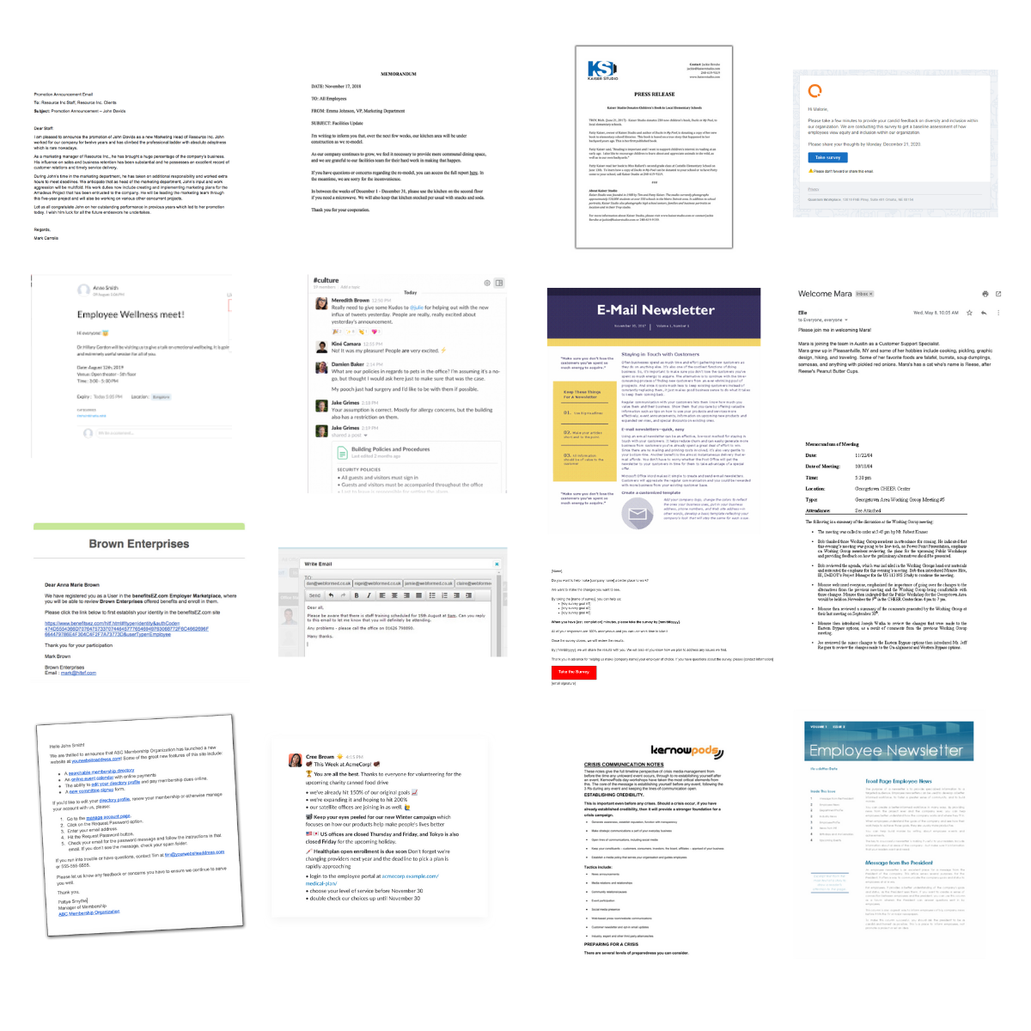
Here’s an example of what it could look like tomorrow, with Workshop:

