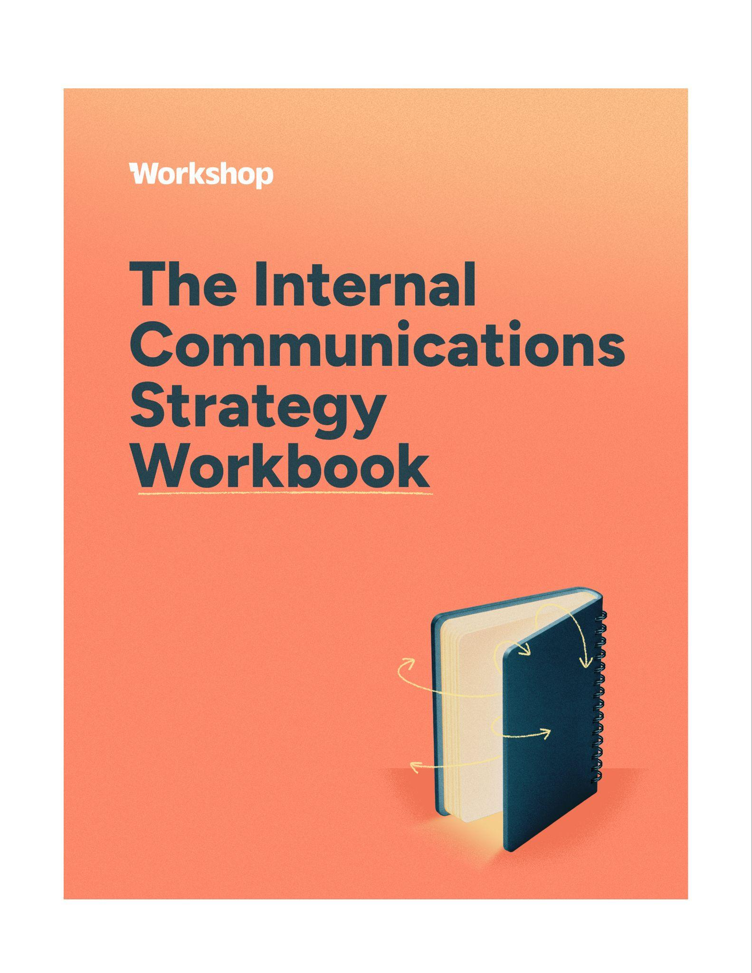
Make this workbook ✨ yours ✨
You’ll want your own version of this strategy workbook (and all the templates!) so you can tweak it, tailor it, and start using it right away. Here’s how to grab a copy from Google Docs:
- Open the link to the guide (it’s view-only to avoid changes to the OG template).
- In the top menu bar, click File > Make a copy.
- Choose where to save it in your Drive and rename it however you’d like!
Want a PDF or Word doc instead? Just go to File > Download, then pick your format:
- PDF (.pdf)
- Word (.docx)
- Plain Text (.txt)
Pro tip: If you’re sharing this with your team, send around the link to your copy so everyone’s on the same page (literally).

We've split your strategy into eight short parts. Each one explains a piece in plain language, then hands you a Build it now template to fill in before you move on. Go start to finish, or jump straight to the part you need. By the end, you'll have a documented strategy!

So glad you’re here!
You already know a documented strategy makes your work sharper — more aligned, easier to defend, and clearly tied to what the business actually cares about. Knowing that and finding time for it are two very different things.
Most comms work is reactive. The requests stack up, the volume climbs, and "just one quick email" quietly becomes the whole plan. Our Internal Communications Trends Report found that plenty of experienced communicators still don't have a strategy written down anywhere… not because they don't care, but because no one ever handed them a spare hour to zoom out.
When you support hundreds (or thousands) of employees across channels, audiences, and stakeholders, that missing hour adds up. Any of these sound familiar?:
- The strategy existed, it just isn’t specific enough to guide the day-to-day work
- Other teams never quite saw how it connected to their work
- The plan is solid… but buried in a folder no one's opened since last spring
- Every department is quietly running its own version of internal comms
- No one ever got the runway to build one in the first place
Here's the good news, and the whole reason this workbook exists: none of that is permanent. A clear plan, a little structure, and steady reinforcement change the entire picture. You'll read a little, build a little, and come out the other side with something real!
A gut-check for every new request
Strategy isn't a document you file away once a year — it's a habit. Next time an idea, campaign, or "can you just…" lands on your desk, run it through these six questions before you touch a single channel:
- What goal are we actually trying to move?
- What's the right approach to get there?
- Who is this really for?
- What do they need to hear right now?
- Does it ladder up to a bigger priority?
How will we know it worked?
Lead with those and you build credibility every single time — for you and for the whole function. Fewer random acts of comms, more work that means something.
So what is a strategy, really?
At its heart, our job is to inspire, inform, and include employees. Your strategy is simply your game plan for doing that on purpose. It's the map for how the work gets done and a rare chance to step back, gather everything you know (the hard numbers and the hallway conversations), and build something that adds up to far more than a stack of one-off sends. Let's build it together, one part at a time. :)
Here’s what we recommend including in a cohesive internal communications strategy:

- Historical data & benchmarks
- Internal communications audit and/or survey results
- “Market research” from your listening tours
- Company goals
- Company values
- The purpose of internal communications at your company
- Department goals
- Internal communication goals (ideally these roll up to company goals)
- Target audiences (segmentation and need)
- Key messages
- Internal communication channels
- Specific programs that need comms support
- Internal communication campaigns
- Annual calendar
- Org charts
- Technology (software)
- Budget allocation
- Metrics/KPIs

Here’s an internal communications strategy outline and framework you can use (including examples of what to include, and some tips and tricks):

Strategic element | Examples | Tips & tricks
Historical data & benchmarks | Employee engagement survey results, eNPS, open rates, | Start with what you already know. Past results can give you a great head start and help you track progress over time.  No internal baseline yet? Check out our Internal Communication Benchmarks Report!
Internal communications feedback & results | Internal communications audit, comms survey, employee preferences, misc. employee feedback | A simple pulse survey goes a long way. Make it quick, and use the insights to prioritize what needs attention.
“Market research” from your listening tours | Feedback from skip-levels, 1:1s, manager meetings, informal chats | Ask open-ended questions. “What’s confusing right now?” or “What’s missing?” can unlock surprising insights.
Company goals | Increase retention, drive revenue, improve onboarding, support culture change | Tie your efforts to business priorities. The more aligned you are, the easier it is to prove your impact.
Company values | “Look on the bright side,” “Take action,” “Communicate with intent” | Weave your values into everyday messages and bring them to life with real stories.
The purpose of internal communications at your company | “To keep employees connected, aligned, and informed” | Write a clear purpose statement. It’ll help you stay focused (and make it easier to get buy-in from leadership).
Department goals | Revenue, leads, applications, hitting deadlines, etc. | This is often skipped, but these goals are often something you can make a huge contribution to (and often, they ladder up to company goals).
Internal communication goals (ideally these roll up to company goals) | “Improve manager communications,” “Drive awareness for benefits changes,” “Increase survey response rates” | Make them specific and trackable. Even better if they align well to company goals.
Target audiences (segmentation and need) | Frontline teams, people managers, new hires, remote employees | Different roles = different needs. Map out your key groups so you can reach them in the ways that work best.
Key messages | “Here’s what’s changing,” “We’re listening,” “You belong here” | These are generic, but make your messages clear, human, repeatable, and on brand. When in doubt, simplify!
Internal communication channels | Email, Slack, intranet, SMS, all-hands meetings, digital signage | Meet people where they are. Use a mix of channels and don’t be afraid to experiment with new ones.
Specific programs that need comms support | Launching a new tool, benefits enrollment, DEI initiatives, culture campaigns | Bring comms in early—ideally when the program is being planned, not just at the rollout.
Internal communication campaigns | Onboarding, monthly newsletter, letter from the CEO, all-hands, etc. | Campaigns work better than one-off messages. Give them a name, a theme, and a bit of personality.
Annual calendar | Monthly all-hands, quarterly newsletters, recognition weeks | Build a shared comms calendar that gives you (and your stakeholders) visibility across the year.
Org charts | Department breakdowns, team structures, leadership snapshots | Make org charts easy to find and update, especially when people are joining or shifting roles.
Technology (software) | Workshop (email, SMS, Pages), AI, Slack, Sharepoint, Asana, Zoom | Use tools that make comms easier, not harder. Bonus points for anything that helps you personalize and track performance.
Budget allocation | Design resources, software, swag, internal events, recognition gifts | A little budget goes a long way. Track how comms supports engagement or adoption to advocate for more. Try our ROI calculator!
Metrics/KPIs | Analytics like open/click rates, engagement trends, message recall, etc. | Tell the story behind the numbers. What worked? What didn’t? What’s next?

Now, the fun part: let’s jump into the workbook!

PART 1 | LISTEN

Start with what you already know
Every good strategy starts with a baseline. Pull what you already have (engagement survey results, eNPS, open and click rates) and let past performance give you a running start. No internal benchmarks yet? No problem! Borrow ours in the Internal Communication Benchmarks Report.
Then, take an honest look at your own setup. The self-assessment below helps you spot the gaps worth your attention first. Score each statement 1 to 5 and watch the low numbers tell you where to start.
BUILD IT NOW | Internal comms audit self-assessment
Rate each statement from 1 (strongly disagree) to 5 (strongly agree). Total it up, then circle the three lowest — that's your short list to tackle first.

Statement | Score 1–5
The role and responsibilities of the internal communicator(s) are clearly understood.
Our internal comms strategy is aligned with our overall business objectives.
Internal communications has a dedicated budget.
Our communication plan shows clear tactics with expected outcomes.
We have a clearly defined content strategy.
Our CEO/President communicates to the company regularly.
I would describe our internal communication as 'transparent.'
Our content has a consistent voice that matches our company brand.
Remote and distributed employees feel informed and connected to the wider org.
Frontline and deskless employees hear updates directly, not just through managers.
There are no communication silos between departments.
We prioritize content by relevance, urgency, and importance.
We actively segment employees into different audiences.
Employees aren't overwhelmed by communication in any one channel.
Employees know where to go to find the information they need.
We have employee feedback channels in place.
We know how different segments respond to different types of information.
We know which channels employees prefer for different types of communication.
We have a single 'source of truth' that houses most (if not all) of our content.
We have a clear plan for how we use every channel available to us.
Internal communication happens consistently, on a regular cadence.
We have an editorial / content calendar.
We use AI to handle production so the team can focus on strategy.
We have qualitative and quantitative metrics for our outcomes.
Our metrics tie clearly to priorities our stakeholders identified.
The data we collect shapes our strategy going forward.
We report on our outcomes to key stakeholders regularly.

Now, hear it straight from employees
The audit captures how you think things are going. A survey captures how employees actually feel — and that's the part that matters most. Keep it short, mix rating scales with a few open-ended questions, and don't skip the messy qualitative stuff from skip-levels, 1:1s, and hallway chats. "What's confusing right now?" can surface more than any dashboard.
BUILD IT NOW | Internal communications survey
Copy these into your survey tool (or an embedded pulse survey).

Overall Communication Satisfaction
How happy are you with the overall internal communication you currently receive?
Rate each on a scale from 1 (Very unsatisfied) to 5 (Very satisfied):
Amount of information 1 2 3 4 5
Frequency of delivery 1 2 3 4 5
Accuracy of content 1 2 3 4 5
Relevance of material 1 2 3 4 5
Style of presentation 1 2 3 4 5

Satisfaction with Communication Channels
Please rate your level of satisfaction with our existing internal communication channels:
(1 = Very unsatisfied, 5 = Very satisfied)
Email 1 2 3 4 5
Slack 1 2 3 4 5
Company newsletter 1 2 3 4 5
Intranet 1 2 3 4 5
Text messages 1 2 3 4 5
Company all-hands meetings 1 2 3 4 5
Department-level meetings 1 2 3 4 5
1:1 meetings with my manager 1 2 3 4 5
Are there other channels being used for internal communications that we're missing here?
Free response

Satisfaction with Communication by Role
Please rate your level of satisfaction with the communication from the following departments / teams / individuals:
(1 = Very unsatisfied, 5 = Very satisfied)
CEO 1 2 3 4 5
Senior leadership 1 2 3 4 5
My department head 1 2 3 4 5
My manager 1 2 3 4 5
My teammates 1 2 3 4 5
Sales 1 2 3 4 5
Marketing 1 2 3 4 5
HR 1 2 3 4 5
Product 1 2 3 4 5
Engineering 1 2 3 4 5
Finance 1 2 3 4 5
Operations 1 2 3 4 5

Communication Effectiveness Statements
Answer the following using a scale of 1–5 (1 = Strongly disagree, 5 = Strongly agree):
I can easily find the information I'm looking for. 1 2 3 4 5
I know where to find the contact information for anyone in the company. 1 2 3 4 5
I feel connected to the company's mission and purpose. 1 2 3 4 5
I know how the company is progressing toward its goals for the year. 1 2 3 4 5
There are communication silos between departments. 1 2 3 4 5
Remote team members feel connected to what's happening inside the company. 1 2 3 4 5
New employees have easy access to common requests. 1 2 3 4 5
I am overwhelmed by the amount of internal communication I receive. 1 2 3 4 5
If I went on vacation for two weeks, I could quickly catch up on what I missed. 1 2 3 4 5
If the information is urgent, a text or phone call is the best way to get a hold of me. 1 2 3 4 5
If I need to share important information with the company, I know where to go. 1 2 3 4 5
I would like to play a more active role in the company's internal communications. 1 2 3 4 5
I enjoy reading the company's internal communications. 1 2 3 4 5

Open-Ended Feedback
Free response questions:
- What information do you wish you had more of?
- What information do you wish you had less of?
- What is a recent example where internal communications worked really well?
- What is a recent example where internal communications failed?
- What other suggestions do you have about improving our communication strategy going forward?

PART 2 | ALIGN

Point everything at a goal

This is where you connect your work to the things leadership already loses sleep over (retention, revenue, onboarding, a big culture shift) so your impact is impossible to miss. The trick is to build a ladder: company goals up top, then the department goals beneath them, then the communication goals that support both.

Fold in your company values and a one-line purpose statement for the comms function while you're here. It keeps you focused and makes buy-in so much easier. And don't skip department goals! They're often where you can make the biggest, most visible contribution, and they usually ladder right back up to the company's.

BUILD IT NOW | Goals ladder
Fill this in for one priority you're working on right now. If you can't draw a straight line from the company goal down to a communication goal, that's your cue to keep digging.

Company goal
Department goal
Communication goal
Campaign
Channels (How comms moves it)
Tactics (How we'll measure it)

Here are some examples to get you started:

Company goal: Get 100 new customers
Department goal: Hire a new customer success team to support those customers
Communication goal: Share the wins & learnings of this new team
Campaign: Department-level campaign for CS
Channels: Email, all-hands
Tactics:
Bi-weekly email newsletter
A segment at all hands that highlights three customers (two positive experiences and one lesson to learn)

Company goal: Reduce safety incidents across distribution centers by 15%
Department goal: Ops rolls out refreshed safety training to all frontline staff
Communication goal: Make sure every deskless employee gets — and acts on — safety updates
Campaign: "Safe Every Shift" frontline campaign
Channels: SMS, Pages, digital signage
Tactics:
Two-way SMS reminders sent by shift and location, no corporate email needed
A mobile engagement hub Page with training videos and a one-tap acknowledgment
Translated messages so every worker gets the update in their language of choice
Draft the whole sequence with Cici, then track opens, clicks, and replies in one dashboard

Company goal: Strengthen culture and connection in a hybrid environment
Department goal: People team launches a new exec visibility program
Communication goal: Make execs more approachable and accessible
Campaign: “A Day in the Life” leadership series
Channels: Email, video, SMS
Tactics:
Monthly email Q&A with an executive (sourced from anonymous employee questions)
Short-form video tours or diary-style clips of execs sharing what they’re working on
SMS campaign for frontline teams featuring quick leadership quotes or updates

QUICK WIN
Write your comms purpose statement in one sentence. Something like "To keep every employee connected, aligned, and informed." Short, clear, and easy to repeat.

PART 3 | KNOW YOUR PEOPLE

Get specific about who you’re talking to
The teams you serve have different days, different pressures, and different ways they want to hear from you. A frontline nurse and a remote engineer don't need the same message, in the same place, at the same time. So map your key groups: what they care about, what trips them up, and the channels that actually reach them. Build a persona for each one, and make sure your deskless and frontline folks get their own too!

BUILD IT NOW | Employee persona template

Fill one out per key audience. Start with a frontline persona and a people-manager persona — the two most likely to get overlooked.

Name / segment
Job title or role
Team
Experience level
Work environment (desk / hybrid / frontline)

Goals What are they trying to accomplish?
Struggles What gets in their way?
What matters to them What do they value at work?
Personality & key qualities How would you describe them?
Preferred tools & channels Where do they actually look for info? (email, SMS, Slack, Pages…)

PART 4 | NAIL THE MESSAGE

Say something worth remembering

Once you know who you're talking to, decide what you actually want them to walk away remembering. The strongest internal messages are simple on purpose — when in doubt, cut a sentence, then cut another.

For anything bigger than a one-off, lock your message before you draft. A message map keeps every email, Slack post, and all-hands talking point pointing the same direction, so the story holds together no matter who's delivering it or where it lands. Want a running start on wording? The AI Prompt Library has prompts written for exactly this.

BUILD IT NOW | Key message map

One map per initiative. Nail the core message first — if you can't say it in a sentence, it's not ready yet!

Initiative / campaign
Primary audience
Core message (one sentence)
Supporting point 1
Supporting point 2
Supporting point 3
Proof / why it's true
Tone (pick 2–3 words)
Primary call to action
What we DON'T want them to think

PART 5 | PICK YOUR CHANNELS

Meet your people where they are

Mix your channels on purpose. Email is still the anchor for most teams — but it's stronger with the right supporting cast:

SMS for the frontline and deskless crowd who never open a corporate inbox. Texts are hard to miss — across Workshop customers, SMS click rates average about 29%, nearly 3x email, with opt-outs around 3%.

Pages when an email blurb isn't enough and an intranet post would get lost — a branded, mobile-friendly landing spot you can update anytime without breaking the link.

Slack, Teams, and SharePoint to reach people inside the tools they already live in.

Translation into 135+ languages so every employee reads in the language they choose.

Don't be afraid to experiment — just decide, on purpose, which message goes where and how often. That's exactly what the matrix below is for.

BUILD IT NOW | Channel matrix

Map your recurring message types to the channels that reach each audience best. We've filled the first two rows as examples, keep going with your own!

Message type | Audience | Primary channel | Backup channel | Cadence | Owner
Urgent / safety | Frontline | SMS | Digital signage | As needed | Ops + Comms
Company news | All employees | Email | Slack / Teams | Weekly | Comms

Reaching your frontline & deskless teams

A huge share of the workforce doesn't sit at a desk (hello nurses, warehouse associates, retail staff, drivers, and line workers, just to name a few!). They rarely open a corporate inbox, but they almost always have a phone in their pocket. If your strategy only lives in comms built for desktops, you're missing the people who often need the message most.

Build frontline reach into your plan

Lead with the phone: Use SMS for time-sensitive updates — shift alerts, safety notices, weather delays, closures, enrollment reminders. No app, no login, no email required.

Give longer content a home: Pair texts with a mobile-ready Page — a branded hub for benefits info, onboarding, or documents that you can update anytime without breaking the link.

Speak their language: Translation into 135+ languages means every worker gets the same information in the language they choose, right from their phone.

Close the loop: Two-way texting lets employees reply, ask questions, claim shifts, or answer a quick poll — so you can actually hear from the field, not just broadcast to it.

Keep lists current: Sync with your HRIS or directory so audiences update automatically as roles, locations, and teams change.

By the way, across Workshop customers, SMS click rates average 29% (nearly 3x higher than email!) with opt-out rates around 3%. For the frontline, a text often lands when nothing else does.

Add frontline audiences to your segmentation

When you map target audiences (on the template on page 9), give deskless teams their own row: what they need to know, when they need it, and which channel actually reaches them. A frontline persona is a great place to start — there's a blank persona template at the back of this workbook.

PRO TIP:

A huge share of the workforce doesn't sit at a desk (nurses, warehouse associates, retail staff, drivers, line workers, just to name a few!). They rarely open a corporate inbox, but they almost always have a phone in their pocket. For the frontline, a text often lands when nothing else does. See how SMS and Pages work together to reach them!

PART 6 | CREATE

Turn plans into campaigns

Here's the shift that gets you out of "random acts of comms": a campaign is just a planned, sequenced series of messages all pulling toward one goal — getting people excited for a launch, enrolled in benefits, or genuinely in the loop with leadership. Intentional and connected beats one-off blasts into the void, every time.

And the best internal comms rarely work alone. When it's clicking, communication is woven into nearly every major initiative in the company. You don't have to own all of it — but getting "internal comms" onto every project brief means you're in the room early, when you can actually shape the outcome (or simply consult, and hand it back).

A filled-in example

Here's what a campaign looks like once it's mapped out! An open-enrollment push that has to reach desk and frontline employees alike:

Field | "Open Enrollment, Handled"
Campaign type | Time-bound (annual)
Company goal | Boost benefits participation and cut down on HR back-and-forth
Department goal (HR) | 90%+ on-time enrollment
Communication goal | Every employee knows what's changing, what to do, and by when
Audience | All benefits-eligible employees (desk + frontline), plus managers
Key message | "Enrollment's open. Here's what's new, what to do, and your deadline — in five minutes or less."
Supporting messages | 1) A few things changed this year. 2) Doing nothing has consequences. 3) Help is one click (or text) away.
Call to action | Review your options and enroll by [date].
Metrics of success | On-time enrollment %, email open >55%, Page visits, SMS click rate, fewer HR questions
Channels | Email, SMS for frontline, a benefits Page, manager talking points
Duration | 3 weeks, plus a final-48-hours reminder
Budget | Minimal — design time and an optional short explainer video

BUILD IT NOW | Internal communications campaign

Your turn! Map your next campaign end to end, one field at a time.

Field | "Title"
Campaign type
Company goal
Department goal (HR)
Communication goal
Audience
Key message
Supporting messages
Call to action
Metrics of success
Channels
Duration
Budget

Let AI carry the busywork

AI went from novelty to normal fast. In our 2026 Trends Report, 42% of communicators said they use it daily, and 68% want it to take the repetitive stuff off their plate. The point isn't to replace you — it's to hand off the production grind so you get more hours for strategy, storytelling, and the human parts only you can do.

Here’s where AI helps most:

- Draft it for you: Give a quick prompt, like "open enrollment reminder for full-time employees" and get back a complete, on-brand email: layout, content, and images.
- Sharpen what you've got: Prefer to write copy yourself? Us too. Paste in your message and ask for a tighter version, a different tone, a skim-friendly layout, or a translation.
- Talk through strategy: Gut-check timing, channel mix, or what counts as a good benchmark, grounded in real comms know-how.
- Make sense of your data: Ask for a campaign summary, a trend worth knowing, or the "so what" behind your open and click rates.

Try it with Workshop
- Meet Cici, the AI agent for internal comms that can plan, write, design, send, and measure with the context of your real comms data.
- The AI email editor drafts and refines emails right where you build them.
- The AI Prompt Library is filled with ready-to-use prompts written for internal communicators. Save one for your next send! And the send after that, and the send after that…
- Workshop AI - see everything Workshop AI can do!
- Workshop Skills - turn the internal comms tasks you do over and over — like planning a month of sends, stack-ranking your latest comms, or giving an email one last check before it goes out — into a saved set of instructions that you can run with a quick click.

A quick word on trust!
AI works best with guardrails. Keep a human in the loop on anything sensitive, protect employee data, and make sure AI-generated content still sounds like your company. A Brand Kit gives every team the templates, colors, and voice to stay on-brand — even when AI is doing the first draft.

BUILD IT NOW | AI prompt starter sheet

Steal our favorite internal comms prompts! Paste one into Cici (or your AI agent of choice), swap in your details, and go! Grab more in the AI Prompt Library.

Use it to… | Prompt
Draft | Draft an on-brand email announcing [change] to [audience]. Keep it under 150 words with a clear subject line and one CTA.
Draft | Write three subject line options for our [campaign] — one direct, one warm, one a little playful.
Draft | Turn these bullet-point notes into a friendly all-hands recap: [paste notes].
Sharpen | Tighten this message and make it skimmable for busy readers, keeping our tone: [paste copy].
Sharpen | Rewrite this update at a plain-language reading level for frontline teams: [paste copy].
Sharpen | Translate this SMS into Spanish and keep it under 160 characters: [paste copy].
Strategy | What's a smart channel mix to reach deskless employees about [topic]?
Strategy | Suggest a 3-week campaign timeline for [initiative], including channels and cadence.
Measure | Summarize this campaign's results in plain language and suggest two next steps: [paste metrics].
Measure | What's a realistic open-rate benchmark for a [industry] company with frontline staff?

Your own go-to prompts

PART 7 | MEASURE

Prove it worked

This is the part that earns you the next budget conversation, so make it a habit, not an afterthought. Watch the signals that tell a story:

Open rates: Who's opening and who isn't? Segment by team, role, or location to spot gaps in awareness — then follow up in a different format or channel where engagement lags.

Click-throughs: Don't just send links, track them. Are people actually clicking into the policy update, the sign-up, the culture content? Low clicks are a nudge to rethink your CTA or placement.

Delivery & list health: Watch bounces and unsubscribes. Workshop filters out out-of-office replies automatically, so you're always working with clean numbers.

Channel comparisons: Running email and SMS together? Put them side by side and lean into whatever earns better opens or responses for that audience.

Campaign-over-campaign: Compare types over time — newsletters vs. onboarding, product vs. leadership — so each campaign teaches the next.

Not a numbers person? No problem. Ask Cici to summarize a campaign and suggest next steps, with your real data behind every answer. Workshop pulls it all together by campaign, so the results live in one place instead of five spreadsheets.

BUILD IT NOW | Campaign metrics snapshot

Fill this in after every campaign. Over time, it becomes your fastest way to spot what's working.

Campaign name
Goal of campaign
Primary channel(s)
Key metric(s)
Target outcome
Actual result
Notes / learnings

Report the story, not just the stats
A monthly recap keeps your wins visible and your stakeholders bought in. Numbers matter — but the story behind them is what people remember. Here's a simple format to reuse. (Pro tip: ask Cici to draft it straight from your campaign data.)

BUILD IT NOW | Monthly internal comms report

Internal Comms Report — [Month] [Year]

Performance at a glance
A few quick lines on how the team is tracking against its goals this month, plus anything notable worth calling out.

This month's wins
- Best-performing email:
- Best-performing SMS / frontline message:
- Best-performing Page or intranet post:
- Best-performing Slack / Teams message:

The story worth telling
One qualitative moment that worked really well this month — bonus points for an employee testimonial if you can grab one.

Scoreboard
KPI | Target | Actual
Internal emails sent
Email open rate
Email click rate
SMS sent
SMS click rate
SMS opt-out rate
Active messages in Slack / Teams
Page / intranet views

Where we're focused next
One thing the team is improving — or a single metric to move — heading into next month.

PART 8 | SUSTAIN

Make it last

The teams that make it stick treat their strategy as a living thing: a shared calendar so everyone can see what's going out and when, a tech stack that makes comms easier (not heavier), a budget you can defend with outcomes, and a clear picture of who approves what.

If you lead a team, a charter keeps everyone rowing in the same direction — purpose, roles, norms, and how you'll work together. And when it's time to ask for more, build the case with numbers: the ROI Calculator and a tight budget proposal do a lot of the convincing for you.

BUILD IT NOW | Team charter

Align your team on why you exist and how you'll work. Fill in each row together.

Team purpose & mission
Goals & objectives (SMART)
Core values
Members & roles
Key stakeholders
Communication & work plan
Group norms
Strengths & skills
Weaknesses & opportunities
Resources & support needed

BUILD IT NOW | Budget proposal

Make the ask easy to say yes to. Build the case with the ROI Calculator, then fill in each section.

Executive overview
The ask and the outcome you're after, in a few sentences.
Current challenges
What's not working today — and what it's costing the business.
Proposed solution
The tool or investment you're recommending, and why it fits.
Metrics for success
How you'll measure ROI. With Workshop, you can show metrics for every campaign and prove improvement over time.
Implementation overview
Who's involved and the rollout steps. Workshop syncs with your HRIS (Workday, ADP), Active Directory, Slack, Teams, and SharePoint to keep lists accurate.
Cost + resources required
One-time and recurring fees. Note any locked-in pricing or annual-plan discounts.
Timeframe
Key dates for signing, setup, and first send.
Background / supporting materials
Graphics, links, and before/after examples for decision-makers.

You did it!

That's it! You've got the bones of a real, documented strategy. Internal comms was never just about sending messages; it's about connection, alignment, and building a place where people feel informed, included, and genuinely inspired to show up. You now have the tools to lead with intention and prove your impact along the way.

Keep it living. Revisit it, tweak it, and let it grow with your organization! And you don't have to do any of it alone: join CommsChat, our community of 1,000+ internal comms pros trading ideas and support, start your week on a positive note with the Happy Monday Club newsletter, and come hang out with us IRL every fall at BrightSide, our employee culture and communications conference in Omaha, Nebraska!

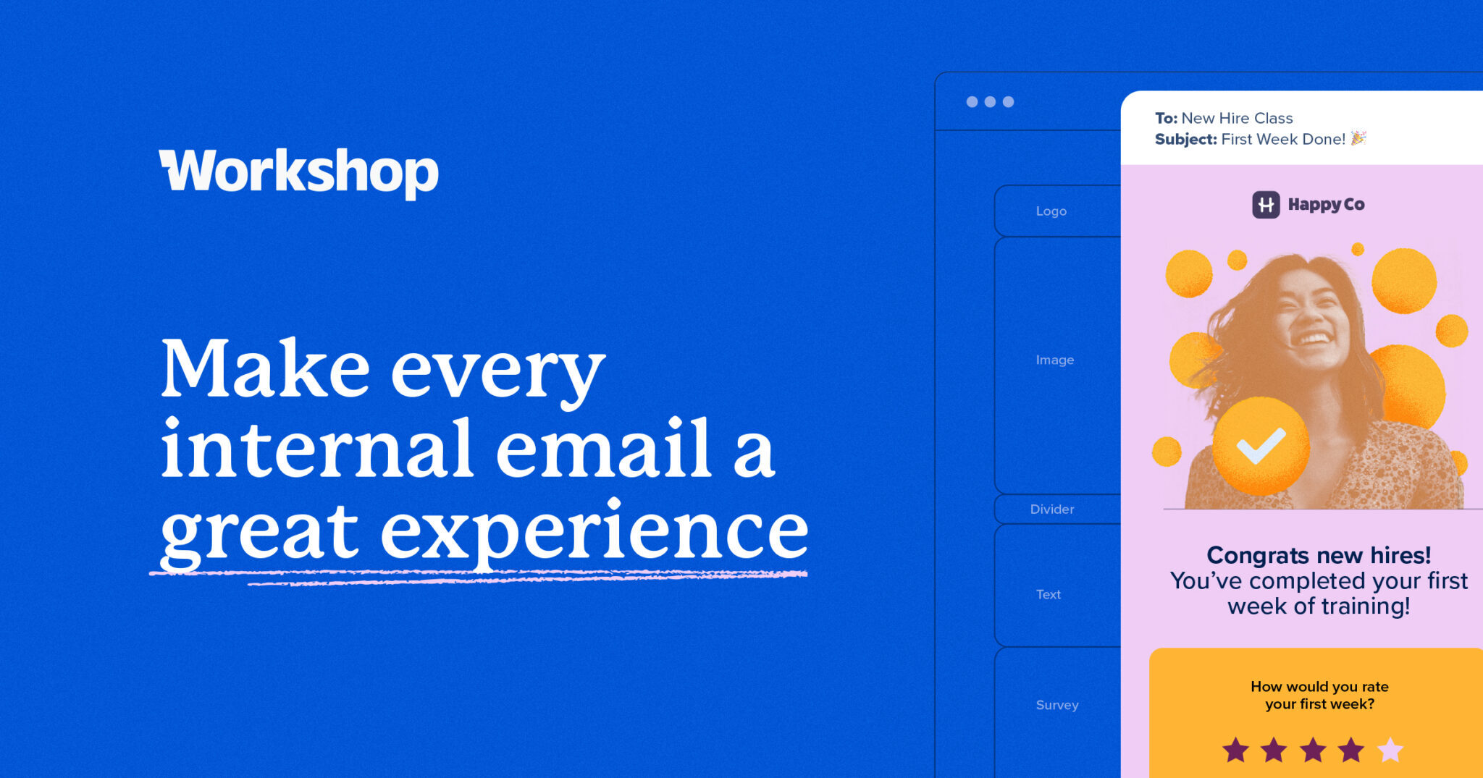

Workshop is built for internal comms teams with simple tools to plan, send, and measure messages that actually reach employees. Whenever you'd like to bring this strategy to life with a lot less busywork, we'd love to show you around!
Schedule a time · Explore the platform · Chat with Cici

Practical tips and templates you'll need to build your strategy + explore our Resource Center and Template Gallery!

1. Historical data & benchmarks
Establish your baseline using open rates, click-throughs, and engagement metrics.
Internal Communication Benchmarks Report

2. Audit & survey insights
Capture the current state through surveys and channel audits. (Blank templates in the back.)
Resource Center · Template Gallery

3. Market research from listening tours
Add qualitative insights from 1:1s, shadowing, and informal interviews.

4. Company goals
Anchor your comms decisions to broader business priorities. (We love the OKR framework!)

5. Company values
Make sure your messaging reinforces and reflects company values.

6. The purpose of internal comms
Write your team's mission statement and define your role internally.
2026 Trends Report · Team Charter Template

7. Department goals
Sync with leaders to support departmental success.

8. Internal communication goals
Set measurable goals that align with the above.
Comms strategy resources

9. Audience segmentation
Create personas and channel preferences by group — including frontline & deskless teams.
Frontline comms · Employee persona template

10. Key messages
Identify messages by goal, audience, and tone.
AI Prompt Library

11. Channel strategy
Match message to method — email, SMS, Pages, Slack, Teams, video, and more.
Explore all channels

12. Programs that need comms support
Prioritize initiatives like onboarding, benefits, change management, and crisis comms.
Onboarding · Benefits · Change management · Crisis comms

13. Internal comms campaigns
Outline core campaigns by quarter.
Campaigns feature · Resource Center

14. Annual calendar
Plan monthly themes, events, and reviews in a shared comms calendar.
Calendar feature

15. Org chart
Understand key roles, approval paths, and influencers.
Stakeholder mapping resources

16. Technology
Inventory and assess tools for reach and measurement.
See all Workshop features · Integrations

17. Budget
Justify your budget with business cases and outcomes.
ROI Calculator · Budget Proposal Template

18. Metrics & KPIs
Define your scoreboard and reporting rhythm.
Analytics features in Workshop

