Welcome to our Budget Proposal template!
Note: Keep this page for yourself! It’s full of helpful information to prepare you to make your case for internal comms budget. Yay!

Before you submit: Build buy-in
A budget request goes to finance under one person's name, but it’s more likely to be approved when several departments already support it! That’s why it’s important to talk to every group the purchase touches before you submit, so no one sees it for the first time in the finance review.
Who to talk to first
- Budget owner(s): confirm the money exists and how a split across departments would work
- Finance partner: ask what format, threshold, and timing they expect
- IT / Security: start the security and integration review early — it's the most common source of delay once a tool is chosen
- Legal / Procurement: check contract terms, data processing, and renewal language
- HR / People: if the tool touches employee data or supports a people goal, get their support on record
- Day-to-day users: a short trial or a quote from the team using it is strong evidence
- Executive sponsor: one leader who will speak for the request if finance pushes back

When to ask
Most budgets are set once a year during annual planning, usually in the last few months before the fiscal year starts. A request made during planning competes for new money, while a request made mid-year has to come out of money a department already has, so you'll need to say exactly whose budget pays for it. So, ask your finance partner when planning starts and when the next deadline is!
New to finance terms? See the Finance glossary section!

What finance looks for
Finance reviews every request on three questions, and the rest of this template is organized around them. If a section doesn't help answer one of them, cut it.

Finance asks | What they need to see | Where it goes in this template
Buy-in & alignment: Who else wants this, and does it serve a company goal? | A named company priority  Which budget(s) pay for it  Agreement from every department involved | The Ask  Company goal alignment
Cost: What's the full cost, and what do we get back? | Recurring vs. one-time costs  Monthly and annual  Value in dollars or hours, with the assumption shown | Cost breakdown  The value
Risk: What could go wrong, and how will we know it worked? | Milestone dates to hold you to  What happens if a date slips  How you'll handle the main risks | Timeline & milestones  Risk summary  Metrics for success

Stats to help build your case
- Global employee engagement fell to 20% in 2025. Low engagement cost about $10T in lost productivity, roughly 9% of global GDP. (Gallup)
- Replacing an employee costs 0.5 to 2 times their annual salary, and 52% of people who quit say it could have been prevented. (Gallup)

Finance glossary
The terms this template uses, in plain language, with where to find each number. When in doubt, your finance partner is the right person to ask. They would rather answer a question now than send the request back later.
Term | What it means, in comms terms | Where to find it / who to ask
Budget owner | The approver for a department's money, the way a leader signs off on a message before it goes out. Nothing gets spent from their budget without their OK. | Usually the department head. Your manager will know.
Budget cycle / annual planning | Finance's editorial calendar. Once a year, departments pitch what they need for next year. Asking inside that window is like getting your story into the newsletter before the deadline instead of after it's sent. | Your finance partner. Ask when it starts and what the deadline is.
Cost center | A distribution list for spending. It's how finance groups costs by team, so they know which department "sent" each expense. | Your finance partner, or an old expense report.
DPA (data processing agreement) | A contract that says how a vendor will handle your employee contact data (names, emails, phone numbers). It's the paperwork behind "is it safe to sync our HR system with this tool?" | Ask the vendor. Most have a standard version ready to share with IT and Legal.
Fiscal year (FY) | The year your company budgets by. It works like your comms calendar's planning year: it may start in January, or in a different month entirely. | Your finance partner or the company handbook.
Loaded rate | What an hour of someone's time really costs the company, including benefits and taxes on top of salary. Use it when you say "this saves us 10 hours a month" so the hours turn into a real dollar figure. | Finance or HR. If they can't share it, use an average salary for the role ÷ about 2,000 hours, and say that's what you did.
Net value | Your results minus your effort. Total value minus total cost. | Where's the value − Cost breakdown.
One-time cost | A launch cost: something you pay once to get started, like the setup work before a campaign goes live. | The vendor's quote; IT for internal setup time.
Payback period | How long until the tool "earns back" what it cost, like how long before a new channel's time savings cover the effort to launch it. Shorter is better! | Year 1 cost ÷ monthly value. See the step-by-step in Where's the value.
Price increase / tier | The price goes up once you pass a set number, such as an employee headcount, the way some email tools charge more once your list grows past a certain size. | The vendor's quote or contract.
Procurement | The review process for new vendors, a bit like your approval workflow for sensitive messages — not every company has a formal one. | Your finance partner will tell you if it applies.
Recurring cost | An ongoing cost, like a subscription you pay every month or year for as long as you use the tool. | The vendor's quote.
Renewal / auto-renew | When the contract ends and whether it continues automatically, like a newsletter subscription that rolls over unless someone unsubscribes. Finance wants the date and how much notice you need to give to cancel. | The vendor's contract or order form.
ROI (return on investment) | Proof the effort was worth it, the same question as "did this campaign move the numbers we care about?" Often shown as value ÷ cost; above 1 means the tool pays for itself. | Where's the value ÷ Cost breakdown.
Run rate | Your "always-on" cost: what the tool costs per year going forward, not counting launch costs. | The recurring rows of the Cost breakdown.
Stakeholder | Same as in comms: anyone affected by the decision or who has to approve it. Build buy-in with them the way you would before a big announcement. | The checklist in Before you submit.

Budget Proposal
Requested by: [Name, Team]
Date: [Date]
Approver(s): [Finance lead, Budget owner]

The Ask
Finance should be able to approve or decline from the first page! Keep “The Ask” to one block, put numbers in tables, and move detail to the appendix.
What we're buying | Workshop internal communications platform, annual plan, for [#] employees.
Problem it solves | One or two sentences. Internal comms currently depend on marketing and IT time, distribution lists go stale, and we can't measure whether employees read what we send.
Total all-in cost | $[ABCD] (recurring $[ABCD]/year + one-time $[0])
Budget source | [Department] budget, [cost center / GL line] (see Budget Source table if split)
Estimated annual value | $[X] / [X] hours saved per year (see The Value section)
Company goal supported | [e.g., 2028 employee retention goal]
Decision needed by | [Date], so we can send the [Month] newsletter on the new platform.

Company Goal Alignment
Name the specific company goal or priority this supports, using the same wording leadership uses. Say how this purchase moves it.

Where to find it: your company's annual goals, OKRs, or the last all-hands deck. If you can't find them, ask your manager which company priorities your team's work rolls up to.

Company goal / priority | How this supports it
[e.g., Improve employee retention to X% in 2028] | [e.g., Consistent, targeted communication by department and location; engagement data shows where employees are disconnected.]
[e.g., AI efficiency / do more with the same headcount] | [e.g., Removes manual newsletter and list work from marketing and IT.]

Cost Breakdown
List every cost, including internal time. Mark each line recurring or one-time so finance can see the run rate separately from launch costs.
Where to find it: the vendor's quote or order form (ask for both monthly and annual pricing); your HR system for the employee count; IT for an estimate of setup hours. If a line is $0, say so!
Line item | Type | Monthly | Annual | Notes
Workshop plan | Recurring | $[XXXX] | $[ABCD] | Additional features beyond email:  SMS, Pages, AI Studio
Implementation / onboarding fees | One-time | n/a | $[0] | No setup fees.
Internal IT setup time | One-time | n/a | [#] hrs (~$[X]) | Gusto, Teams and SharePoint integrations.
Renewal / auto-renewal | Recurring (future) | +$[ZZZ] | +$[ZZZ x 12] | Applies once contract ends
Total Year 1 |  |  | $[Total]

Why not use the tools we already have?

This is the most common question finance will ask. Your current tools can send a message. The case is what they cost you in time, workarounds, and missing data. Swap in the names of your actual tools and keep only the rows that matter for your organization.
What we need | With our current tools [e.g., Outlook, Teams, SharePoint] | With a dedicated internal comms platform (Workshop)
Accurate distribution lists | Updated by hand, often by IT, and they go out of date as people join, leave, or move. | Synced from our HR system automatically; segment by team, location, or role without IT.
Branded, readable emails | Hard to format consistently; often needs help from marketing or design. | Drag-and-drop builder, templates, and a Canva integration.
Knowing who read it | Little or no data on opens, reads, or clicks. | Engagement analytics broken down by role, region, and channel.
Reaching frontline and deskless employees | Separate tools, each posted to by hand. | One send across email, Slack, Teams, intranet, two-way SMS, and mobile-friendly landing pages.
Approvals and planning | Email threads and spreadsheets. | Approval workflows, editorial calendar, and collaborative drafting.
Fixing a mistake after sending | Send a correction email. | Edit links after the email is sent.
Automation | Every send is manual. | Scheduled and recurring sends, automatic resends to people who didn't open, and new-hire and milestone journeys (on some plans).
AI help | General AI tools that don't know our lists or past results. | Cici, an AI assistant that drafts messages, targets audiences, and summarizes results.

Bottom line for finance: [One sentence, e.g., "Our current tools cost $0 more, but they cost about 10 hours a month in manual work and give us no way to prove anyone read our messages."]

The Value
Pick the levers that apply (one is fine) and give a dollar or hour estimate for each. Show the assumption so finance can check the math. Delete rows that don't apply!
Not sure where to start? Run your numbers through Workshop's ROI calculator first, then follow the step-by-step below.

How to calculate value, step by step

You actually don't need a finance background for this! A cautious estimate with the assumption written down beats a big number finance can't check.

Count the hours. For one normal week, have each person involved jot down the time they spend on the work this tool would replace (building lists, formatting, chasing approvals, cross-posting). Multiply the weekly total by 4 for a monthly figure.

Turn hours into dollars. Ask your finance partner or HR for a loaded hourly rate. If they can't share one, use an average salary for the role divided by about 2,000 working hours a year, and say that's what you did.

Example: 10 hrs/month × $65/hr × 12 months = $7,800 a year.

Add hard savings. Add any tool you can cancel (its annual cost) and any fees or contractor spend you'll avoid.

Subtract the cost. Total value minus Year 1 cost from the Cost breakdown = net value.

Work out payback. Year 1 cost ÷ monthly value = months until the tool pays for itself.

Example: $6,000 cost ÷ $650 a month in value ≈ 9 months.

Round down. If the number looks too good, cut your hour estimate in half and see if the case still holds.
Value lever | Estimate (annual) | Assumption / how we calculated it
Saves people cost | $[7,800] | [10] hrs/month of marketing and IT time on internal comms x $[65]/hr loaded rate x 12 months. Or: avoids hiring a [part-time comms coordinator] at $[X]/yr.
Saves time | [120] hrs/yr | Distribution lists sync automatically from Gusto instead of [2] hrs/week of manual list updates.
Reduces risk | [Qualitative or $] | Fewer messages sent to outdated lists (e.g., former employees, wrong locations). Audit trail for policy communications.
Drives revenue / company initiative | [Metric] | Supports [initiative]; e.g., higher read rates on [benefits enrollment / AI rollout] communications.
Replaces / consolidates tools | $[X] | Retires [current tool(s)] at $[X]/yr when the contract ends [date].
Total estimated value | $[X] / [X] hrs | Net of cost: $[Value - Cost]. Payback in ~[#] months.

Timeline & Milestones
Give finance dates they can hold you to beyond ROI: did it launch on time, and did value show up when you said it would?
Milestone | Target date | Owner | Risk if missed
Decision / budget approval | [Date] | [Finance] | Can't launch before the [Month] newsletter.
Contract signed | [Date] (within 7 business days of approval) | [Requester / Legal] | Annual-plan discount or locked pricing may expire.
Integrations live (Gusto, Teams, SharePoint) | [Date] (+5 business days) | [IT] | Lists would need manual upload at launch.
Go-live: first campaign sent | [Date] | [Comms owner] | Newsletter goes out the old way for one more cycle.
First value: [3] campaigns live + first metrics report | [Date] (~30 days after go-live) | [Comms owner] | Delays the first read on value estimates.

Risk Summary

Two or three lines on the biggest risks and how you'll handle them!

[Top risk, e.g., IT capacity delays setup]: [mitigation, e.g., IT review already started; vendor supports setup].

[Second risk, e.g., low adoption]: [mitigation, e.g., trial completed; one owner per department].

If we don't do this: [cost of waiting, e.g., another quarter of manual lists and no read-rate data].

Metrics for Success
How you’ll know it's working after launch, with a baseline and a target for each.
Where to find it: use your current email tool's reports for today's open rates. If you can't measure something today, write "Not measured today" as the baseline.
Metric | Baseline today | Target | Check-in
Email open / read rate on internal campaigns | [Unknown / X%] | [X%] | [90 days]
Hours spent on internal comms by marketing and IT | [X] hrs/month | [X] hrs/month | [90 days]
Number of targeted campaigns sent | [X]/month | [X]/month | [6 months]

Background / Supporting Materials
Add graphics, links, PDFs, etc. to help stakeholders and key decision-makers if needed.
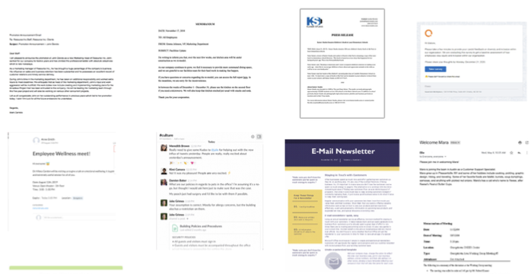
Here's an example of what our communication looks like today:

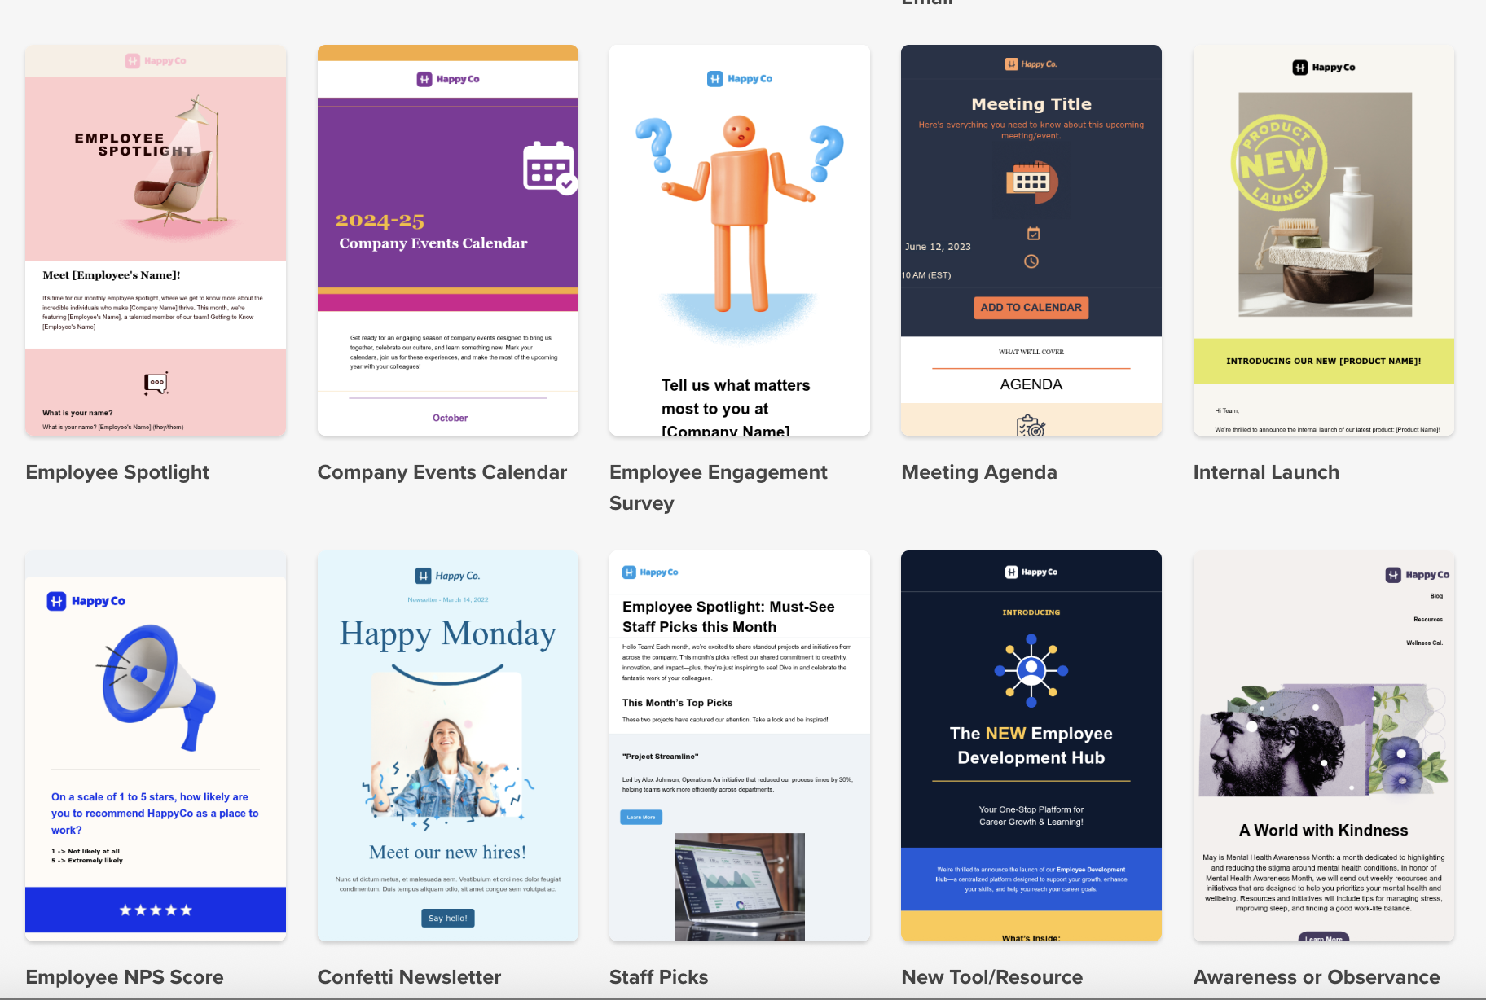
Here's an example of what it could look like tomorrow, with Workshop:

